Embassy of Bangladesh and Mission to the European Union
Brussels

Press Release

ERD Secretary meets EIB Vice-President in Luxembourg

Luxembourg, 16 May 2024

Secretary, Economic Relations Division (ERD), Government of Bangladesh, Md. Shahriar Kader Siddiky met Nicola Beer, Vice-President of European Investment Bank (EIB) at the EIB Headquarters in Luxembourg yesterday (15 May 2024). The meeting was held in a very cordial atmosphere with both sides discussing the ongoing and possible future investments by EIB in Bangladesh.
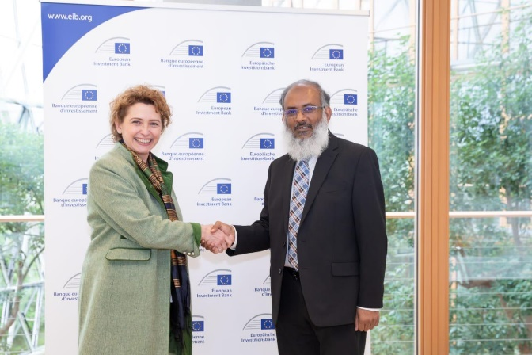
Pic:1 Nicola Beer, Vice-President of EIB welcomed
Md. Shahriar Kader Siddiky, Secretary, ERD

Vice-President Beer welcomed Secretary Siddiki and his delegation to the EIB Headquarters and commended the impressive sociology-economic development of Bangladesh under the visionary and dynamic leadership of Prime Minister Sheikh Hasina. She recalled her meeting with Prime Minister of Bangladesh during the EU’s first Global Gateway Forum in Brussels in October 2023 when she was Vice-President of the European Parliament. Vice-President Beer said that Bangladesh is one of the biggest partners of EIB’s loan and grant programme along the European Commission including through the Global Gateway Initiative. During the meeting, Secretary Siddiki thanked the EIB for its steadily growing support to Bangladesh in its developmental journey. He expressed the willingness of Government of Bangladesh to further expand its partnership with EIB and requested its support particularly in the areas of climate change, renewable energy, health including vaccine research and development, agriculture, sustainable infrastructures including railways, leather industry and others. Vice-President Beer responded positively and said that EIB is also eager to be a stronger partner of Bangladesh in its development initiatives including a smooth transition of the country’s LDC graduation in 2026. The discussion also included the issues of possible framework agreements, providing technical assistance to Government of Bangladesh, and launching periodic institutional consultations between the two sides.
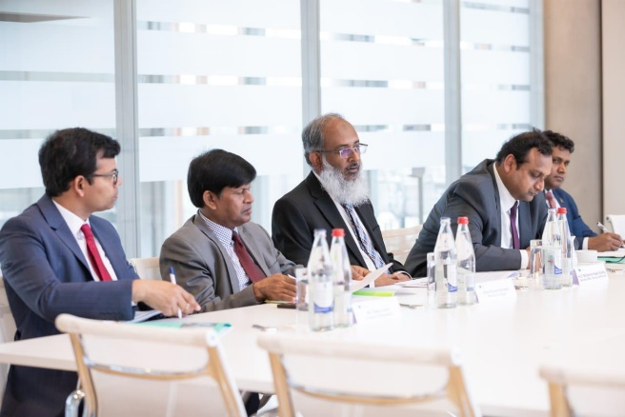 | 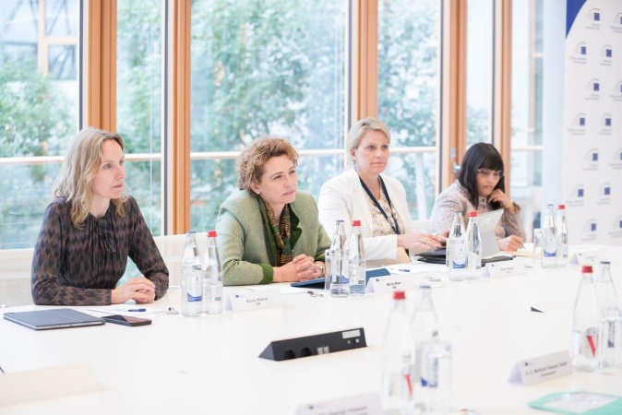
Pic: 2 & 3 The discussion was going on about future possible investments by EIB in Bangladesh.

Secretary Siddiky invited Vice-President Beer to visit Bangladesh at her earliest convenience. Vice-President Beer said that she is looking forward to visiting Bangladesh very soon.

Secretary Siddiky was accompanied by Uttam Kumar Karmaker, Additional Secretary, ERD, Mahbub Hassan Saleh, Ambassador of Bangladesh to Belgium, Luxembourg and the European Union, Md. Rejaul Islam, Counsellor and Md. Alamgir Hossain, First Secretary, Embassy of Bangladesh in Brussels.
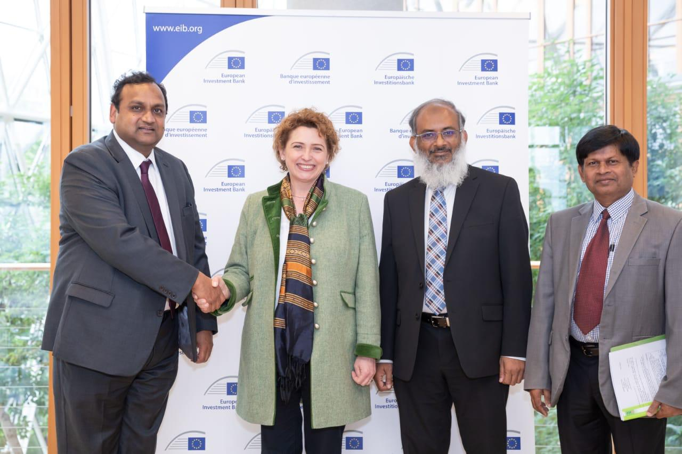
Pic: 4 Mahbub Hassan Saleh, Ambassador thanked Nicola Beer
Vice-President of EIB for a very productive meeting

Vice-President Nicola Beer was accompanied by Nicole Birtsch, Head of Vice-President’s Office, Katrin Bock, Investment Officer and Arundhati Pal, Loan Officer, European Investment Bank.

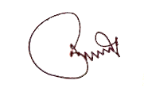
Md. Alamgir Hossain
First Secretary (Economic)
Embassy of Bangladesh in Brussels.
Email: fseco.brussels@erd.gov.bd
alamgir1310@gmail.com

